FINAL REPORT
ON
HERITAGE TREASURE:
AN IN-DEPTH ANALYSIS OF UNSESCO WORLD HERITAGE SITES IN TABLEAU
Submitted in partial fulfilment of the requirments for the
degree of
BACHELOR OF BUSINESS
ADMINISTRATION
By
P. MOHAN BALAJI
(24B91M0035)


SAGI RAMAKRISHNAM RAJU ENGINEERING
COLLEGE, BHIMAVARAM
2026-2027

Table of Contents
- Abstract
- Introduction
- Literature Review
- Problem Statement
- Objectives
- Scope
- Software Requirements
- Hardware Requirements
- Dataset Description
- Data Collection
- Data Preparation
- Business Questions
- Data Visualization
- Dashboard Design
- Story Design
- Performance Testing
- Flask Integration
- Results
- Advantages
- Limitations
- Future Scope
- Conclusion
- References

ABSTRACT
Data visualization has become an essential component of Business Intelligence because it enables organizations to convert complex datasets into meaningful graphical representations. Tableau is one of the most widely used Business Intelligence tools for creating interactive dashboards and reports without extensive programming knowledge.
This project, titled "Heritage Treasures: An In-Depth Analysis of UNESCO World Heritage Sites Using Tableau," focuses on analyzing UNESCO World Heritage Sites using Tableau Public. UNESCO World Heritage Sites represent locations that possess outstanding cultural, natural, or historical significance and require preservation for future generations. The dataset contains information such as site name, country, region, category, inscription year, geographical location, and danger status.
The project begins with collecting the UNESCO World Heritage Sites (2019) dataset from Kaggle. After collecting the dataset, it undergoes preprocessing to remove duplicate records, correct data types, and ensure consistency. The cleaned dataset is then connected to Tableau Public, where multiple visualizations are created to answer important business questions.
Several interactive visualizations, including treemaps, pie charts, bar charts, line charts, maps, and category distribution charts, are developed to explore the dataset. These visualizations are combined into a responsive dashboard that enables users to analyze heritage sites using filters such as country, region, category, and danger status. A Tableau Story is created to present the findings in a logical sequence.
The dashboard is published through Tableau Public and integrated into a Flask web application to improve accessibility. Performance testing is conducted to verify dashboard loading speed, filter functionality, calculated fields, and visualization accuracy.
The final outcome of this project is an interactive Business Intelligence solution that helps users understand global heritage distribution, identify endangered heritage sites, study inscription trends, and support better decision-making through effective data visualization.
Keywords: Tableau, UNESCO, Data Visualization, Dashboard, Story, Business Intelligence, Flask, Heritage Sites.

INTRODUCTION
Business Intelligence (BI) has become one of the most important technologies for analyzing large datasets and supporting data-driven decision-making. Tableau is a leading BI tool that enables users to transform raw data into meaningful visualizations.
UNESCO World Heritage Sites represent places of exceptional cultural, natural, and historical importance around the world. As the number of heritage sites grows, analyzing this information becomes increasingly complex. This project addresses this challenge by developing an interactive Tableau dashboard that enables users to explore UNESCO heritage data effectively.
The dashboard includes country-wise analysis, regional trends, endangered heritage sites, category distribution, and interactive filtering, allowing users to gain valuable insights quickly and efficiently.

LITERATURE REVIEW
- Several studies have demonstrated that data visualization improves decision-making by presenting complex information in a simple and interactive manner.
- Tableau has been widely adopted in industries such as healthcare, finance, education, and tourism due to its ability to create real-time dashboards without extensive programming.
- UNESCO provides open datasets that help researchers analyze global heritage conservation. However, raw tabular data is difficult to interpret, making visualization tools like Tableau essential for extracting meaningful insights.

PROBLEM STATEMENT
- The UNESCO World Heritage dataset contains hundreds of records with multiple attributes, making manual analysis difficult. Traditional spreadsheets cannot effectively present relationships between countries, regions, categories, and inscription trends.
- Therefore, an interactive dashboard is required to simplify analysis and support better decision-making.

OBJECTIVES
- Analyze UNESCO World Heritage data.
- Build interactive Tableau dashboards.
- Study country-wise heritage distribution.
- Identify endangered heritage sites.
- Analyze inscription trends over time.
- Publish dashboards through Tableau Public.
- Integrate dashboards into a Flask application.

SCOPE
The project can be used by:
- Researchers
- Government organizations
- Students
- Tourists
- Cultural heritage organizations
- The dashboard enables quick exploration of UNESCO heritage information through interactive visualizations.

SOFTWARE REQUIREMENTS
The engineering pipeline built for this project relies on three distinct industry-standard software tools. Each tool represents a specific layer of the data engineering stack: Data Storage Data Analytics & Visualization (Tableau), and Application Development & Deployment Python, Flash, Microsoft Excel and Window 11.
A. Tableau (The Data Analytics & Visualization Tier):
- Functional Role: Business Intelligence and Visual Data Modeling Workspace.
- Project Application: Tableau connects directly to the processed dataset to handle multi-dimensional visual processing. It is used to build the Bio-Energy Plant Capacity Map, the Seasonal Supply Fluctuations bar charts, and the Machinery Load Matrix scatter plots.
- Engineering Benefit: Tableau translates complex numerical tables into high-density visual insights. For engineering evaluation committees, it uncovers hidden data vectors—such as geographic production clusters for power plant placement and mechanical stress peaks on harvesting equipment—that are impossible to detect in a raw database.
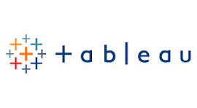
Fig.1

B. Python:
- Functional Role: Data Processing and Backend Automation Engine.
- Project Application: Python serves as the primary data engineering layer for this project. It is used to parse the raw UNESCO dataset, perform statistical cleaning, handle missing values, and execute the backend logic required to transform raw strings into actionable analytics.
- Technical Benefit: It enables rapid data prototyping and complex numerical operations. By utilizing robust data analysis libraries, Python eliminates manual errors in data curation and provides the necessary computational overhead required for deep-dive heritage status evaluation and predictive modeling.

Fig.2
C. Flask:

- Functional Role: Web-Service Framework and Backend Infrastructure.
- Project Application: Flask manages the web-service architecture, providing a lightweight backend environment to serve processed data files to the dashboard interface and ensuring high-availability data access.
- Technical Benefit: Its modular, micro-framework architecture ensures minimal latency in data delivery. For development, it provides a scalable interface that supports future expansion, allowing for seamless API integration and interactive data-retrieval services without system bloat or unnecessary complexity.


Fig.3

C. Microsoft Excel:
- Functional Role: Data Curation and Spreadsheet-based Analysis.
- Project Application: Excel serves as the primary data ingestion and pre-processing layer. It is used to normalize raw UNESCO datasets, rectify structural inconsistencies, and validate data integrity. This provides a clean, structured foundation before the data is ingested into Python scripts or the Tableau workspace.
- Technical Benefit: Its intuitive interface allows for rapid data verification and categorical filtering. Excel acts as an essential buffer for tabular data management, ensuring that any missing or erroneous records are identified and resolved before moving to more advanced visual processing stages.


Fig.4

D. Windows 11:
- Functional Role: Core Development and Execution Environment.
- Project Application: Windows 11 acts as the host operating system, providing the ecosystem for the entire development stack. It manages the runtime environment for Python scripts, executes the Flask backend server, and provides the stable resource management required to run Tableau Desktop for dashboard rendering.
- Technical Benefit: The operating system provides a robust, multi-threaded environment optimized for development workflows. Its advanced resource management ensures stable performance of data pipelines and seamless integration between different software tools, minimizing compatibility overhead and maximizing productivity during the project lifecycle.


Fig.5

HARDWARE REQUIREMENTS
- Intel Core i5 Processor
- 8 GB RAM
- 10 GB Storage
- Internet Connection

DATASET DESCRIPTION
Dataset Name:
UNESCO World Heritage Sites (2019)
Dataset Format:
CSV
Dataset Source:
Kaggle
Main Attributes:
- Heritage Site Name
- Country
- Region
- Category
- Danger Status
- Inscription Year
- Latitude
- Longitude

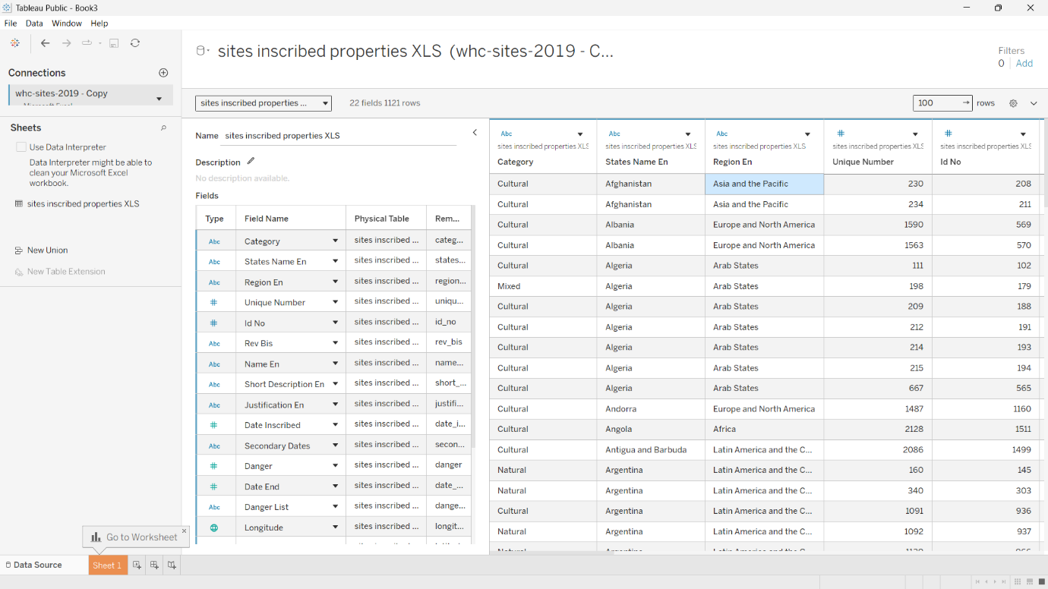

DATA COLLECTION
The dataset was downloaded from Kaggle, verified using Microsoft Excel, and imported into Tableau Public. The data was checked for completeness before visualization.

DATA PREPARATION
The following preprocessing tasks were performed:
- Removed duplicate records
- Checked missing values
- Verified country names
- Converted date fields
- Removed unnecessary columns
- Validated latitude and longitude

BUSINESS QUESTIONS
Examples:
- Which country has the highest number of UNESCO heritage sites?
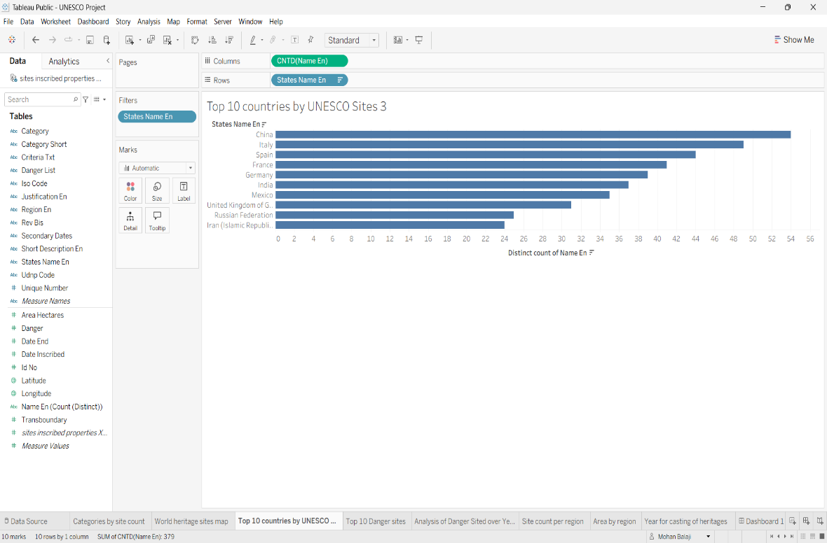
Fig.6

- How many sites are currently in danger?

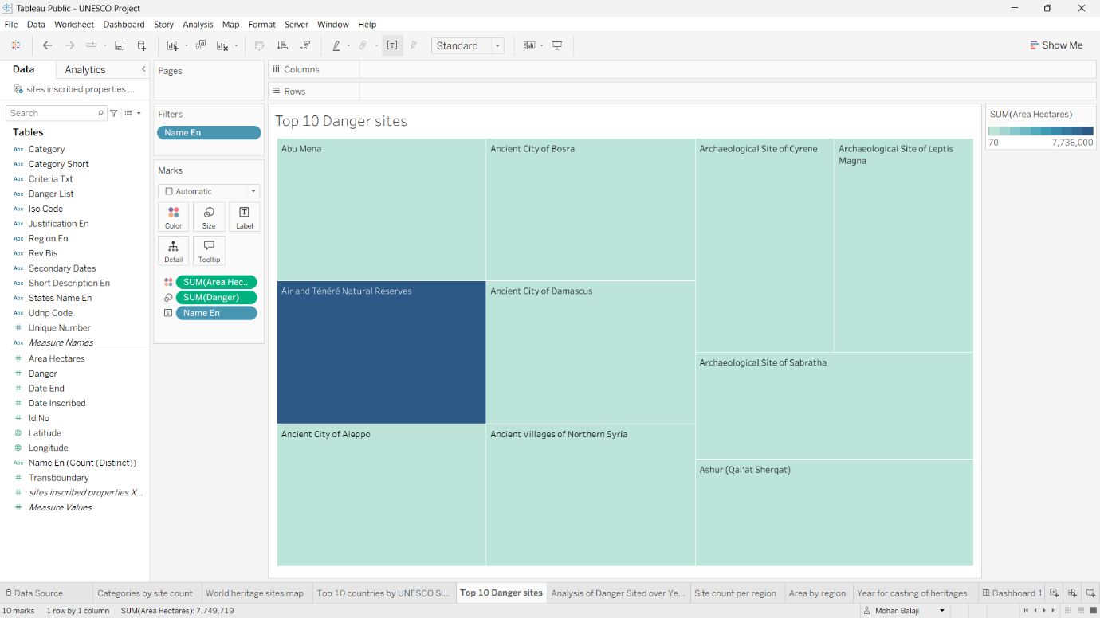
Fig.7

- Which region has the highest number of inscriptions?

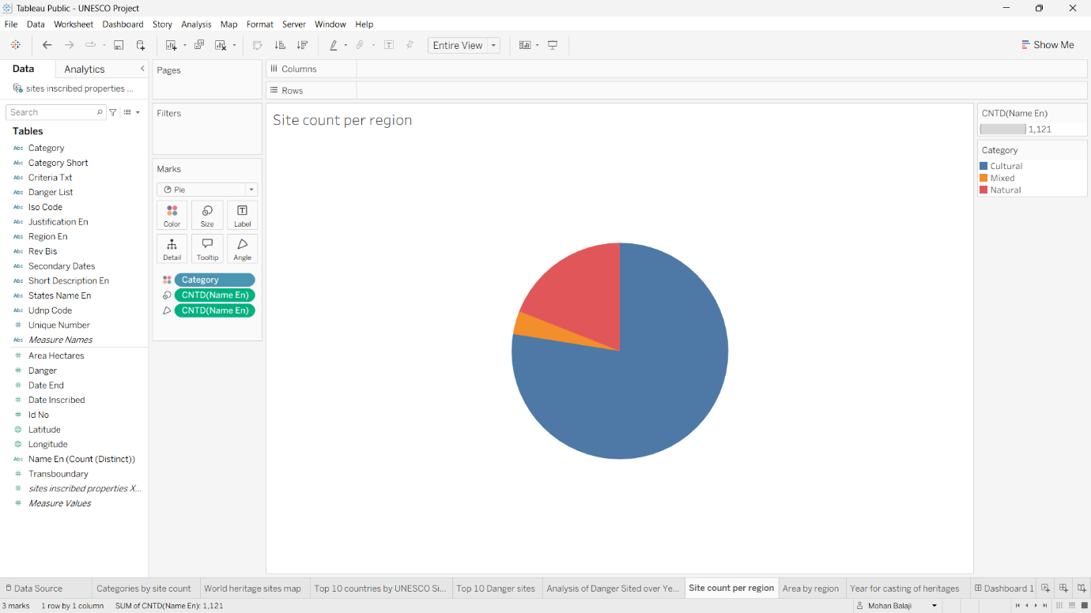
Fig.8

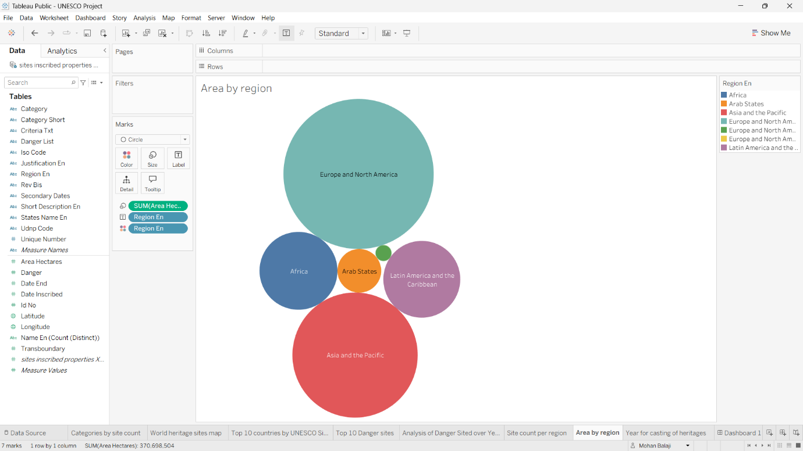
Fig.9
- What is the distribution of heritage categories?

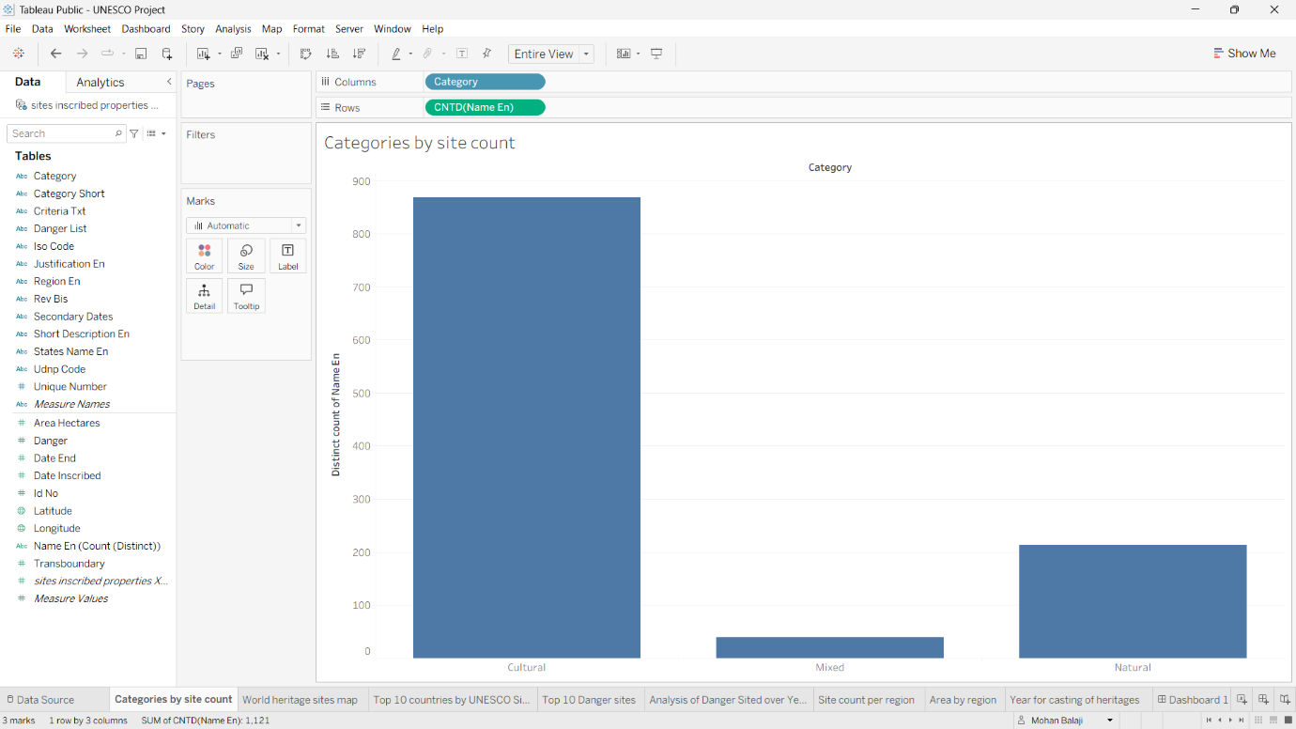
Fig.10
- How have inscriptions changed over time?

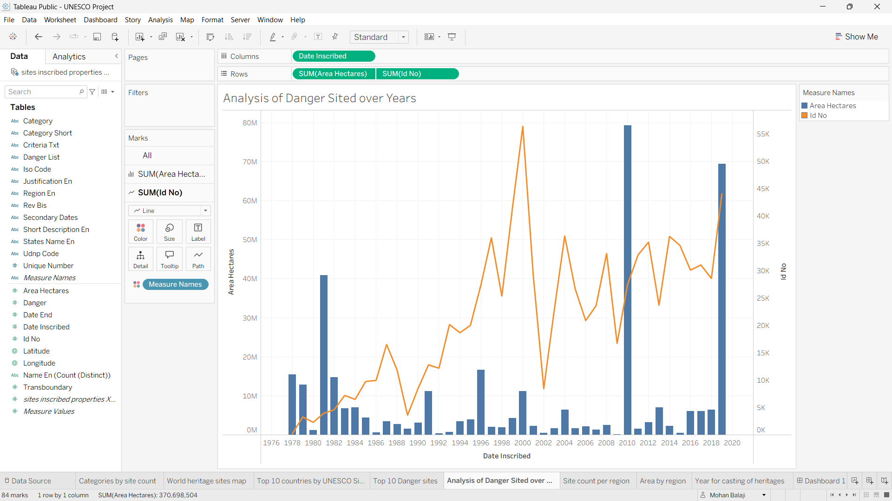
Fig.11

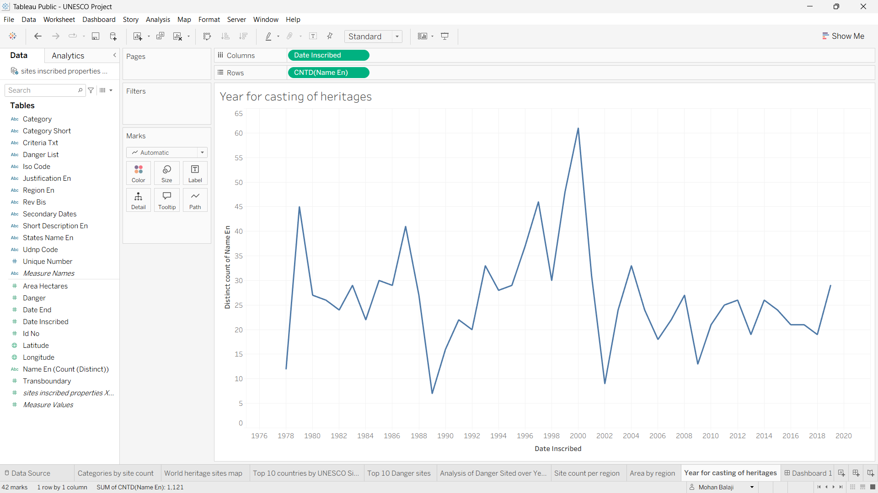
Fig.12

DATA VISUALIZATIONS
Created Visualizations:
- Treemap
- Pie Chart
- Line Chart
- Bar Chart
- Map
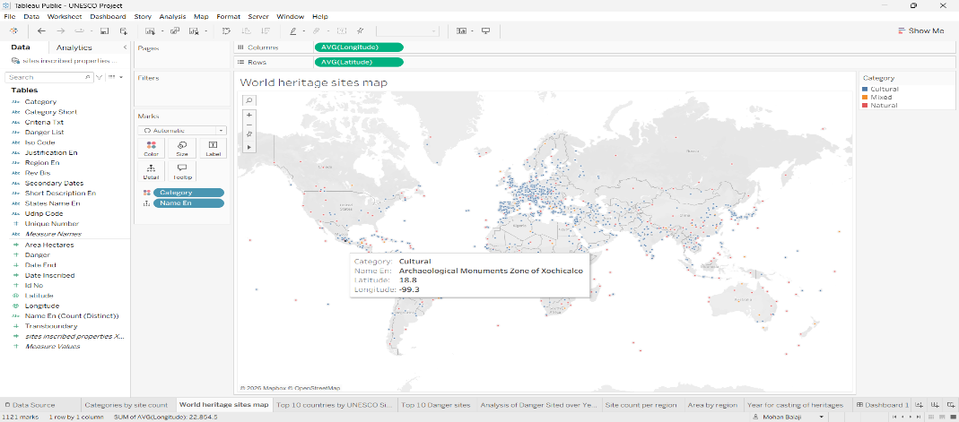
Fig.13
- Stacked Bar Chart
- Each visualization answers a specific business question.

DASHBOARD
The dashboard combines all visualizations into one interactive interface.
Features include:
- Country Filter
- Region Filter
- Category Filter
- Danger Filter
- Interactive Tooltips

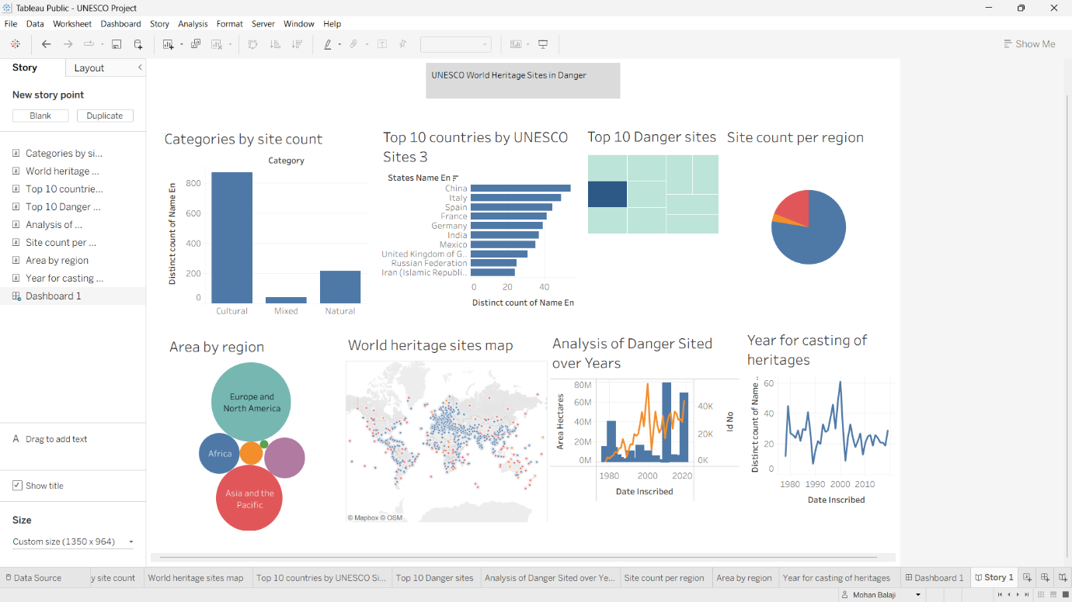
Fig.14

STORY
The Tableau Story contains five story points:
- Introduction
- Country Analysis
- Danger Analysis
- Regional Trends
- Conclusion
This allows users to understand the analysis step by step.

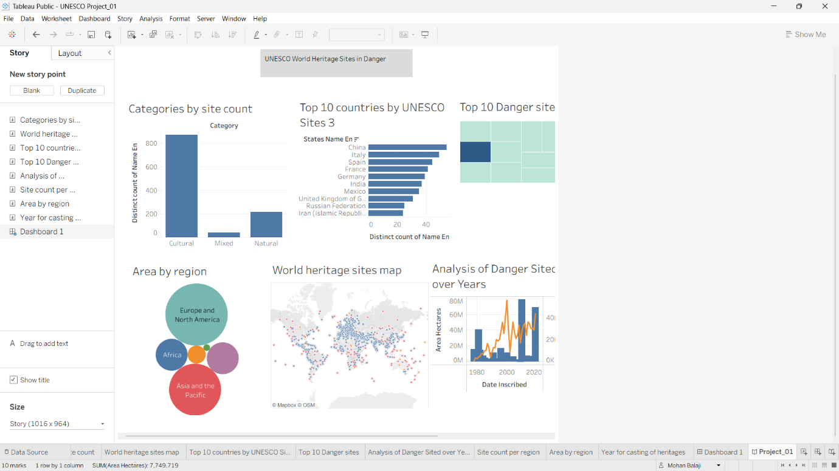
Fig.15

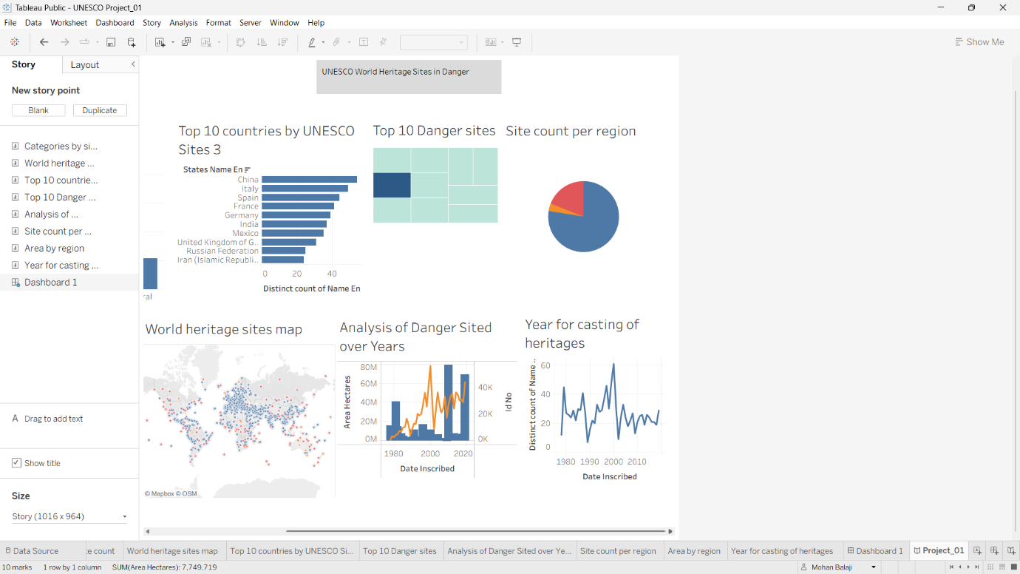
Fig.16

PERFORMANCE TESTING
Testing confirmed:
- Dataset loaded correctly
- Dashboard responsive
- Filters working properly
- Charts accurate
- Story navigation successful
- Tableau Public link accessible

FLASK INTEGRATION
The Tableau dashboard was embedded into a Flask web application using the Tableau Public embed code. This allows users to access the dashboard through a web browser.

RESULTS
The dashboard successfully provides:
- Country-wise heritage analysis
- Endangered site identification
- Regional trend analysis
- Interactive data exploration
- Improved decision-making

ADVANTAGES
- Easy to use
- Interactive
- Fast analysis
- Attractive visualizations
- Better decision-making
- Supports tourism and heritage research

LIMITATIONS
- Depends on dataset quality
- Tableau Public requires internet
- Static historical dataset

FUTURE SCOPE
- Future improvements include:
- Real-time UNESCO API integration
- AI-based predictive analytics
- Mobile-responsive dashboard
- Advanced GIS mapping
- Multilingual support

CONCLUSION
This project successfully demonstrates the use of Tableau as a Business Intelligence tool for analyzing UNESCO World Heritage Sites. Through interactive dashboards, visualizations, and stories, users can easily explore global heritage information and gain meaningful insights. The integration of Tableau with Flask further enhances accessibility by making the dashboard available through a web application. Overall, the project meets its objectives and showcases the effectiveness of data visualization in supporting research, education, and decision-making.
- References
- UNESCO World Heritage Centre.
- Tableau Public Documentation.
- Salesforce Tableau Learning Resources.
- Kaggle – UNESCO World Heritage Sites Dataset.
- Flask Official Documentation.

PROJECT REFERENCES & ACCESS LINKS
For your convenience, all project resources can be accessed via the links provided below:
- UNESCO Project Dataset:
https://www.kaggle.com/datasets/ujwalkandi/unesco-world-heritage- sites/data?select=whc-sites-2019.csv

- Tableau Dashboard:
https://public.tableau.com/views/UNESCOProject_01/Project_01?:language=en-US&publish=yes&:sid=&:redirect=auth&:display_count=n&:origin=viz_share_link

- Tableau Story Presentation:
https://public.tableau.com/shared/PM8YBKJ2P?:display_count=n&:origin=viz_share_link

